Title of manuscript

John Optician*, Maria Optometrist#, Peter Ophthalmologist$

*Czech Technical University in Prague, Faculty of Biomedical Engineering, #Affiliation of Author 2, $Affiliation of Author 3

email:john.optician@fbmi.cvut.cz

***Abstract:*** Begin the abstract one line below author names and affiliations. The abstract summarizes key findings in the paper. It is a paragraph of 50 words or less (3-4 lines). For the **keywords**, select up to 4 key terms for a search on your manuscript's subject.

**Keywords:** refractive errors, lenses, myopia, vision correction

1. Introduction

Begin the Introduction part one line below the Keywords. The Introduction part should provide a basic outline of a presented problem, aims, and own contribution of the authors. Do not change the manuscript template. The length of the manuscript should be **2 or 4 pages**. References are noted in the text [1-3] and cited at the end of the paper.

1. Theoretical description of problem

Further sections of the manuscript should be divided with respect to the described problem (e.g. theoretical description, analysis and methods, experiment, discussion, conclusion). All the text of the manuscript uses Arial font style with size 10 points.

* 1. **Subsection headings**

Subsection headings are left-justified, Arial font style 10-pt. bold italic. Capitalize the first word, acronyms, and proper nouns.

* 1. **Equations**

Use common fonts like Times Roman in your math equations. A math reference in a paragraph sentence such as  is not numbered. Use Equation editor in Microsoft Word for creating equations in the text. The mathematical formulas and equations are numbered subsequently using a right-aligned tab and numbers in parentheses, for example

, (1)

where *d* is the vertex distance and the value of back vertex power  of the lens is given by

, (2)

where  is the back focal length. You can cite the equation in the manuscript text using their numbers in parentheses. For example, the back vertex power is described using Eq.(1).

* 1. **Figures and tables**

Figures are centered. Use or insert .jpg, .tiff, .png or .gif illustrations. Figure captions go below figures. For example, Fig.1 presents a scheme of a spectacle lens correction of a myopic eye.

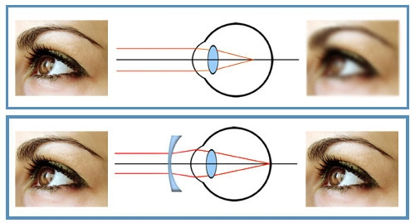

**Fig.1** Scheme of spectacle lens correction of myopic eye

Results of measurements or statistical data analysis, and experimental data are usually presented in tables. Tables are centered and numbered. The caption goes below the table. For example, the results of the comparison of three methods are given in table 1.

|  |  |  |  |
| --- | --- | --- | --- |
| Number | Method 1 | Method 2 | Method 3 |
| *n* = 20 | 0.2951 | 0.2865 | 0.3288 |
| *n* = 50 | 0.2858 | 0.2859 | 0.2743 |
| *n* = 100 | 0.2838 | 0.2858 | 0.2736 |
| *n* = 200 | 0.2855 | 0.2858 | 0.2818 |
| *n* = 1000 | 0.2858 | 0.2858 | 0.2865 |

**Tab.1** Comparison of three methods

1. Experiment and analysis

Further sections of the manuscript can be added to the manuscript if it is needed. It is necessary to preserve the same style of the template in all the manuscript.

Further sections of the manuscript can be added to the manuscript if it is needed. It is necessary to preserve the same style of the template in all the manuscript.

Further sections of the manuscript can be added to the manuscript if it is needed. It is necessary to preserve the same style of the template in all the manuscript.

Further sections of the manuscript can be added to the manuscript if it is needed. It is necessary to preserve the same style of the template in all the manuscript.

Further sections of the manuscript can be added to the manuscript if it is needed. It is necessary to preserve the same style of the template in all the manuscript.

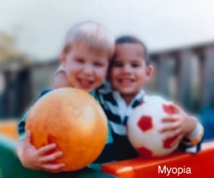

**Fig.2** Simulation of vision of myopic eye

Further sections of the manuscript can be added to the manuscript if it is needed. It is necessary to preserve the same style of the template in all the manuscript.

Further sections of the manuscript can be added to the manuscript if it is needed. It is necessary to preserve the same style of the template in all the manuscript.

Further sections of the manuscript can be added to the manuscript if it is needed. It is necessary to preserve the same style of the template in all the manuscript.

Further sections of the manuscript can be added to the manuscript if it is needed. It is necessary to preserve the same style of the template in all the manuscript.

Further sections of the manuscript can be added to the manuscript if it is needed. It is necessary to preserve the same style of the template in all the manuscript.

Further sections of the manuscript can be added to the manuscript if it is needed. It is necessary to preserve the same style of the template in all the manuscript.

Further sections of the manuscript can be added to the manuscript if it is needed. It is necessary to preserve the same style of the template in all the manuscript.

Further sections of the manuscript can be added to the manuscript if it is needed. It is necessary to preserve the same style of the template in all the manuscript.

Further sections of the manuscript can be added to the manuscript if it is needed. It is necessary to preserve the same style of the template in all the manuscript.

Further sections of the manuscript can be added to the manuscript if it is needed. It is necessary to preserve the same style of the template in all the manuscript.

Further sections of the manuscript can be added to the manuscript if it is needed. It is necessary to preserve the same style of the template in all the manuscript.

1. Conclusion

The Conclusion part of the manuscript should summarize shortly the fundamental results of the work and own contribution of the authors.

Acknowledgment

You can place here an acknowledgment for a support and help with the research project or experimental study.

References

1. TIMOSHENKO, S. P., WOINOWSKY-KRIEGER S., *Theory of Plates and Shells*, McGraw Hill Higher Education, New York, 1964.
2. HENCKY., H., On the stress state in circular plates with vanishing bending stiffness, *Zeitschrift für Mathematik und Physik*, 63, 1915, pp. 311–317.
3. Van Derlofske, J. F., Computer modeling of LED light pipe systems for uniform display illumination, *Proc. SPIE* 4445, 2001, pp.91-95.